Futuristic View of Helping the Impaired

Pavithra. E

Computer Science and Engineering

RMK Engineering College

Thiruvallur , India

[pavygal17@gmail.com](mailto:pavygal17@gmail.com)

Shanmukhi.NComputer Science and Engineering

RMK Engineering College

Thiruvallur ,India

nain14219.cs@rmkec.ac.in

**Abstract—** Developing interactive chips is an emerginginterdisciplinary research area, which requires collaborationbetween a wide range of discipline. In this paper, we have made an attempt to combine three different techniques- socially interactive robotics, remote neural monitoringand floating data to help the ‘deaf and dumb’ people.Theinteractive chip when implanted in thebrain of those people will help them to communicate at theirbest. This leads to a new revolution in which there will be no more problems forthe dis-abled. Thisprogressively develops confidence in them to goon par with other people without any difference.

KEYWORDS-Interactive chips,socially interactive robots, remote neural monitoring, floating data,deaf and dumb,communicate.

I.SOCIALLY INTERACTIVE ROBOTICS

Creating intelligent chips is a developing interdisciplinary examination region, which requires coordinated effort between an extensive variety of controls, including mechanical autonomy, wellbeing sciences, brain research, gerontology, remote neural monitoring,air in plain view and human-PC communication.

As of late, there is an expanded hobby here because of numerous reasons. Expanding capacities ofsocial intelligent chips, expanding requirements of individuals for help i.e. diversely abled individuals all round the world.On the other hand, there is an expanding deficit in numbers of wellbeing experts and parental figures. At that point this intelligent chips would be a decent substitution of all the above. This intelligent chip will be of mix of socially assistive robot, remote neural checking and air in plain view with the assistance of Bluetooth. Socially assistive robots are not quite the same as social robots and stimulation robots, which give moderately basic human-robot cooperations. Interestingly, socially assistive robots are required to give a wide scope of administrations to bolster every day exercises of clients.

In most momentum examination endeavors to plan socially assistive robots, the attention is on outlining new automated operators that can associate with individuals by different means. Since individuals don't have much involvement with robots, subsequently we give them a disentangled adaptation of the robot i.e. an intelligent chip which helps them to maintain a strategic distance from middle of the road individual in the middle. The target of this paper is to create computerized reasoning with in a man to defeat his incapacity.

II.SOCIALLY INTERACTIVE CHIPS

Social robots are exemplified specialists that are a piece of a heterogeneous gathering: a general public of robots or humans.They can perceive one another and take part in social collaborations, they have histories(perceive and decipher the world as far as theirown experience), and they unequivocally correspond with and gain from one another.

Growing such "individual social" robots requires the utilization of models and procedures unique in relation to "gathering capabilities are required than with social interfacerobots.

Agreeable: Robots that ace effectively draw in with people keeping in mind the end goal to fulfill interior social points (drives, feelings, and so on.).

These robots require profound models of social comprehension.

Reciprocal to this rundown we can include the accompanying three classes:

Socially arranged: Robots that are encompassed by a social domain that they see and respond to Socially arranged robots must have the capacity to recognize other social specialists and different articles in the environment.

Socially inserted: Robots that are: (an) arranged in a social domain and cooperate with different operators and people; (b) fundamentally combined with their social surroundings; and (c) at any rate in part mindful of human interactional structures (e.g., turn-taking) .

Socially astute: Robots that show parts of human style social insight, taking into account profound models of human perception and social ability .

III.SOCIALLY INTERACTIVE ROBOTS

For the reasons of this paper, we utilize the expression "socially intuitive robots" to portray robots for which social communication assumes a key part. We do this, not to present another class of social robot, but instead to recognize these robots from different robots that involve"conventional" human–robot communication, for example, those utilized as a part of teleoperation situations.

In this paper, we concentrate on distributed human–robot communication. In particular, we portray robots that show the accompanying "human social" attributes:

•express and/or see feelings;

•communicate with abnormal state dialog;

•learn/perceive models of different operators;

•establish/keep up social connections;

•use characteristic signs (look, motions, and so on.);

•exhibit particular identity

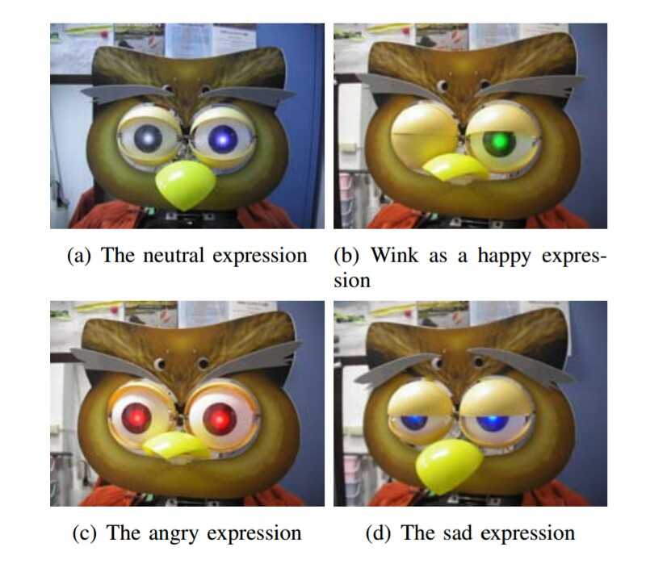

Socially intuitive robots can be utilized for an assortment of purposes: as exploration stages, as toys, as instructive apparatuses, or as helpful guides. The basic, fundamental presumption is that people like to cooperate with machines similarly that they connect with other individuals.

Socially intuitive robots work as accomplices, companions or collaborators, which implies that they have to display acertain level of versatility and adaptability to drive the connection with an extensive variety of people. Socially intelligent robots can have distinctive shapes and capacities, running from robots whose sole reason and just assignment is to draw in individuals in social interactions(Kismet, Cog, and so on.) to robots that are built toadhere to social standards so as to satisfy a scope of undertakings in human-occupied situations (Pearl, Sage, and so forth.)

Some socially intuitive robots utilize profound models of human cooperation and master effectively support social collaboration. Others demonstrate their social ability just in response to human conduct, depending on people to trait mental states and feelings to the robot. Notwithstanding work, fabricating a socially intelligent robot requires considering the human on the up and up: as architect, as onlooker, and as collaboration accomplice. Socially intuitive robots are critical for areas in which robots must show distributed connection abilities, either in light of the fact that such aptitudes are required for unraveling particular assignments, or in light of the fact that the essential capacity of the robot is to cooperate socially with individuals.

One zone where social association is attractive is

that of "robot as convincing machine" , i.e., the

robot is utilized to change the conduct, emotions or dispositions of people. This is the situation when robots intercede human–human collaboration, as in extreme introvertedness treatment .

Another zone is "robot as symbol" , in which the

robot capacities as a representation of, or delegate for, the human. For instance, if a robot is utilized for remote correspondence, it might need to act socially keeping in mind the end goal to viably pass on data In specific situations, it might be attractive for a robotto build up its collaboration aptitudes after some time. For example,a pet robot that goes with a kid through hischildhood might need to enhance its aptitudes keeping in mind the end goal to keep up the tyke's advantage. Learned improvement of social (and other) aptitudes is an essential worry of epigenetic apply autonomy .

A few analysts plan socially intelligent robots essentially to think about epitomized models of social behavior.For this utilization, the test is to manufacture robots that have an inborn thought of sociality, that create social abilities and bond with individuals, and that can indicate compassion and genuine comprehension. At present, such robots remain a far off objective, the accomplishment of which will require commitments from other exploration zones for example, counterfeit life, formative brain research and sociology.Although socially intelligent robots have as of now been utilized with achievement, much work stays to build their viability. For instance, all together for socially intuitive robots to be acknowledged as "normal" cooperation accomplices, they require more modern social aptitudes, for example, the capacity to perceive social setting and tradition.

Moreover, socially intuitive robots will in the long run need to bolster an extensive variety of clients: differentgenders, diverse social and social foundations, distinctive ages, and so on. In numerous present applications, social robots connect with just in transient collaboration (e.g., a historical center visit) and can stand to treat all people in the same way. In any case, when a robot turns out to be a piece of a man's life, that robot should have the capacity to regard him as a particular person.

In the accompanying, we intently look at the ideas

brought up in this early on segment. We start by describingdifferent outline strategies. At that point, we show a scientific classification of framework parts, concentrating on the configuration issues interesting to socially intelligent robots. We finish up by examining open issues and center difficulties.

IV.REMOTE NEURAL MONITORING

A portion of the nations included in such projects incorporate USA, UK, Spain, Germany and France. As of late, the National Security Agency (NSA) of the US has added to an exceptionally effective strategy for controlling the human mind. This innovation is called Remote Neural Monitoring (RNM) and is required to upset wrongdoing recognition and examination.

What is it?

RNM works remotely to control the cerebrum keeping in mind the end goal to peruse and identify any criminal thought occurring inside the brain of a conceivable culprit. Research concentrates on have demonstrated that the human mind thinks at a rate of around 5000 bits per secondand does not have the ability to contend with supercomputers performing through satellites, inserts and biotelemetry. The human cerebrum has an unmistakable arrangement of bioelectric reverberation framework. For the RNM framework, supercomputers are being utilized and, hence, with its offer, supercomputers some assistance with canning send messages through an embedded individual's sensory system to impact their execution desiredly.

RNM has been created after around 50 years of neuro-electromagnetic automatic human experimentations. By researchers, inside of a couple of years it is normal that DNA microchips will be embedded in the human mind which would make it innately controllable. With RNM, it will be conceivable to peruse and control a man's enthusiastic manners of thinking alongside the intuitive and dreams. At present, far and wide, supercomputers are observing a huge number of individuals at the same time with the pace of 20 billion bits every second particularly in nations such as USA, Japan, Israel and numerous European countries.RNM has an arrangement of specific projects working at various levels, similar to the signs knowledge framework which utilizes electromagnetic frequencies (EMF), to invigorate the mind for RNM and the electronic cerebrum join (EBL). The EMF Brain Stimulation framework has been composed as radiation insight which implies getting data from accidentally began electromagnetic waves in the earth. Be that as it may, it is not identified with radioactivity or atomic explosion. The recording machines in the signs insight framework have electronic hardware that research electrical action in people from a separation. This PC produced mind mapping can always screen all electrical exercises in the cerebrum. The recording help framework interprets singular mind maps for security purposes.

What does it do?

For purposes of electronic assessment, electrical movement in the discourse focus of the mind can be made an interpretation of into the subject's verbal contemplations. RNM can send encoded signs to the sound-related cortex of the cerebrum straightforwardly bypassing the ear. This encoding helps in recognizing sound correspondence. It can likewise perform electrical mapping of the mind's movement from the visual focus of the cerebrum, which it does by bypassing the eyes and optic nerves, along these lines anticipating pictures from the subject's cerebrum onto a video screen. With this visual and sound memory, both can be envisioned and examined. This framework can, remotely and non-intrusively, distinguish data by digitally unraveling the evoked possibilities in 30-50Hz, 5 millwatt electromagnetic outflows from the cerebrum. The nerves deliver a moving electrical example with a moving attractive flux which then puts on a consistent measure of electromagnetic waves. There are spikes and examples which are called evoked possibilities in the electromagnetic outflow from the mind. The fascinating part about this is the whole practice is completed with no physical contact with the subject.

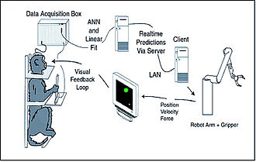The EMF outflows from the mind can be decoded into current musings, pictures and sounds in the subject's cerebrum. It sends entangled codes and electromagnetic heartbeat signs to enact evoked possibilities inside the cerebrum, in this way creating sounds and visual pictures in the neural circuits. With its discourse, sound-related and visual correspondence frameworks, RNM takes into account a complete varying media mind to cerebrum join or a cerebrum to-PC join.

Obviously, the instrument needs to decipher the reverberation recurrence of every particular site to balance the insertion of data in that particular area of the mind. RNM can likewise distinguish listening to by means of electromagnetic microwaves, and it additionally highlights the transmission of particular charges into the intuitive, delivering visual unsettling influences, visual visualizations and infusion of words and numbers into the cerebrum through electromagnetic radiation waves. Likewise, it controls feelings and contemplations and peruses musings remotely,causes torment to any nerve of the body, considers remote control of conduct, controls rest designs through which control over correspondence is made simple. This can be utilized for wrongdoing examination and security administration.

Concerns

With all the given advantages of RNM for following the unlawful and misleading exercises, there are numerous worries and dangers being called attention to by human rights activists and different researchers. The offices of human rights the world over have scrutinized RNM as an infringement of fundamental human rights on the grounds that it damages security and the pride of musings and exercises of life. A few nations have dissented against it and allude to it as an assault on their human and social equality. The researchers dissenting against the utilization of RNM trust that individuals who have been embedded automatically gotten to be organic robots and guinea pigs for RNM exercises in the appearance of security. This is an imperative organic concern identified with microchip implantation, which is a shrouded innovation utilizing microwave radiations for the control of the brain.

Researchers trust that like leukemia and the carcinogenic dangers postured by cellular telephones which additionally emanate microwaves, RNM can likewise posture comparative dangers to a subject's general wellbeing as the warming impact of tissues with the velocity of light is a known impact of powerful microwave and electromagnetic heartbeat weapons.

Along these lines, RNM remains a dubious innovation which is being utilized as a part of numerous nations for security support and reconnaissance.

IV.FLOATING TOUCH

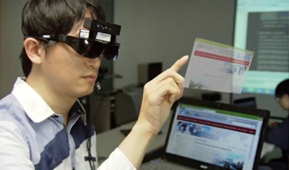AirView makes use of a technology known as Floating touch.

There are two types of capacitive sensors used for touch-screens, mutual capacitance and self-capacitance. Mutual capacitance makes multi-touch detection possible. Self-capacitance generates a stronger signal than mutual capacitance, which allows accurate detection of the finger further away from the sensors.Floating touch works by combining these two capacitive technologies on the same touch screen, at the same time.

V.CONCLUSION

We have come-up with an idea, connecting all the above mentioned technologies.The RNM chips are implanted into the ‘deaf and dumb' people’s brains,leaving them with a wearable device such as a ‘wristwatch’ that exhibits ‘air-view' logic. The chip and the device are connected through ‘Bluetooth’. The result would be, the thought of the disabled, in their subconscious mind ,by means to get communicated, will be displayed on the device , that can be revealed to others to fulfill the needs of the impaired.

ACKNOWLEDGEMENT

We would like to thank Dr. K. L. Shanmuganadhan for offering us with this immense opportunity to showcase our talents.

REFERENCE

1.http://www.cs.cmu.edu/~illah/PAPERS/socialrobotics

2.http://robotic.media.mit.edu/wp-content/upload

3.http://robotics.USC.edu/publications/media/upload

4.Brain Computer interface

5.Virtual touch screen floats in mid-air

6.Wikipedia